

Even in the Darkest of Times, There is Light

A Ted Leonsis Production

Directed by
Bill Guttentag & Dan Sturman

World Premiere: Sundance Film Festival, January 20th, 2007
Running Time: 89 minutes
Rating: This film is not yet rated.
Official Website: www.nankingthefilm.com

Distribution contact: Press Contacts:
CAA 42 West
Micah Green Cynthia Swartz, Michael Kupferberg,
Rene Ridinger, Scott Feinstein
310-288-4545 646-723-9697
mgreen@caa.com cynthia.swartz@42west.net michael.kupferberg@42west.net
rene.ridinger@42west.net
scott.feinstein@42west.net
NANKING

CAST

Rev. John Magee Hugo Armstrong
Chang Yu Zheng Rosalind Chao
Lewis Smythe Stephen Dorff
George Fitch John Getz
Minnie Vautrin Mariel Hemingway
Yang Shu Ling Michelle Krusiec
Mills McCallum Chris Mulkey
John Rabe Jurgen Prochnow
Sakai Hiroshi Sonny Saito
Bates Graham Sibley
Chinese Soldier Robert Wu
Stage Manager Mark Valley
Bob Wilson Woody Harrelson

FEATURING

Cao Zhi Kun
Chang Zhi Qiang
Ding Yong Qing
Jiang Gen Fu
Ding Guo Yong
Li Gao Shan
Li Su Fen
Luo Zhong Yang
Ni Cui Ping
Xia Shu Qin
Wang Wen Yu
Wu Zheng Xi
Zhang Xiu Hong
Zhou Ji Mu

Directed by Bill Guttentag & Dan Sturman
Screenplay by Bill Guttentag & Dan Sturman & Elisabeth Bentley
Story by Bill Guttentag & Dan Sturman
Produced by Ted Leonsis
Producers Bill Guttentag
Michael Jacobs
Co-Producer Violet Du Feng
Director of Photography Buddy Squires
Editors Hibah Frisina, A.C.E.
Charlton McMillan
Michael Schweitzer
Music by Philip Marshall
Selections performed by The Kronos Quartet
Line Producers Dylan Nelson
Katie Strand
Karen Lin
Associate Producers Izumi Tanaka
Makiko Wakai
Jo Ann Jacobs

SYNOPSIS

A powerful, emotional and relevant reminder of the heartbreaking toll war takes on the innocent, Nanking tells the story of the Japanese invasion of Nanking, China, in the early days of World War II. As part of a campaign to conquer all of China, the Japanese subjected Nanking – which was then China’s capital – to months of aerial bombardment, and when the city fell, the Japanese army unleashed murder and rape on a horrifying scale. In the midst of the rampage, a small group of Westerners banded together to establish a Safety Zone where over 200,000 Chinese found refuge. Unarmed, these missionaries, university professors, doctors and businessmen – including a Nazi named John Rabe – bored witness to the events, while risking their own lives to protect civilians from slaughter.

The story is told through deeply moving interviews with Chinese survivors, chilling archival footage and photos of the events, and testimonies of former Japanese soldiers. At the heart of Nanking is a filmed stage reading of the Westerners’ letters and diaries, featuring Woody Harrelson, Mariel Hemingway and Jurgen Prochnow. Through its interweave of archival images, testimonies of survivors, and readings of first hand accounts, the film puts the viewer on the streets of Nanking and brings the forgotten past to startling life.

Nanking is a testament to the courage and conviction of individuals who were determined to act in the face of evil and a powerful tribute to the resilience of the Chinese people – a gripping account of light in the darkest of times.

HISTORY

Japan had a presence in mainland Asia since 1931, when the annexed Manchuria and established Manchuoko, a puppet Japanese state. In August 1937, Japan began a full-scale invasion of China. The Japanese army fought a series of fierce ground battles in Shanghai and launched a massive air raid campaign against Nanking, then China’s capital. By November 12th, Shanghai had fallen and by December 13th, the Japanese had defeated the defending Chinese army and invaded the city of Nanking.

The events now known as ‘the rape of Nanking’ lasted approximately six weeks. The city was looted and burned, and marauding Japanese soldiers unleashed a staggering wave of violence on Nanking’s population. According to the summary judgment of the International Military Tribunal for the Far East – also known as the Tokyo Trials, “estimates indicate that the total number of civilians and prisoners of war murdered in Nanking and its vicinity during the first six weeks of the Japanese occupation was over 200,000. Approximately 20,000 cases of rape occurred in the city during the first month of the occupation.”

Prior to the fall of the city, many Chinese fled the approaching troops and all foreign citizens were ordered to evacuate. A group of 22 European and American expatriates, however, refused to leave. Despite devastating air strikes and the threat of an oncoming army, these Westerners – including John Rabe, a Nazi businessman; Bob Wilson, an American surgeon; and Minni Vautrin, the American headmistress of a missionary college – remained behind in order to set up a Safety Zone to protect civilians. Some two hundred thousand refugees crowded into the Zone, which spanned two square miles. During the brutal occupation, Safety Zone committee members vehemently protested the army’s actions to the Japanese authorities, but the carnage continued. Every day John Rabe, Minnie Vautrin, and the others fought to keep the Safety Zone’s boundaries intact and the refugees safe.

By March, the worst of the violence had subsided and the army moved on, leaving behind an occupying force. The refugee camps in the Safety Zone were disbanded, though intensive relief efforts continued. The Japanese set up a puppet government that ruled Nanking until the end of the war. In 1948, the Tokyo Tribunal convicted Iwane Matsui, commander of Japanese forces in central China, of war crimes and sentenced him to death. Emperor Hirohito and his uncle Prince Asaka, who commanded the troops that actually occupied Nanking during the massacre, were spared.

Today, Many Japanese know little about the wartime atrocities their country committed throughout Asia. Seventy years later, the invasion of Nanking remains a divisive issue. Some Japanese ultra-conservatives deny or minimize the massacre; to this day, many Japanese believe stories of atrocities in Nanking are exaggerations and lies. Soon after producer Ted Leonsis decided to create a documentary about Nanking, mass protests broke out in China over Japanese approval of textbooks that called the Nanking massacre an ‘incident.’ The protests made headlines around the world. Many in Asia are also outraged by the former Japanese prime minister’s annual pilgrimage to the Yasukuni Shrine in Tokyo. Along with millions of soldiers who died for the Japanese Emperor, Yasukuni – which translates as ‘peaceful nation’ – enshrines the souls of 14 class A war criminals.

In advance of December 2007, the 70th anniversary of the invasion of Nanking, the Chinese and Japanese governments have convened a joint committee of historians in an attempt to agree upon a common version of the history of the Sino-Japanese conflict, including what happened in Nanking.

NANKING TIMELINE

1931 Japanese occupy Manchuria, establish Manchuoko (puppet Japanese state)

1937
August 13 Japanese attack Shanghai
August 15 First air raid on Nanking
November 12 Shanghai falls
November 15 Chiang Kai Shek government begins leaving Nanking
November 16 Nanking International Committee for the Safety Zone conceived
November 22 Safety Zone proposal sent to the Japanese authorities, rejected weeks later
November 25 John Rabe wires Hitler for help establishing Safety Zone
December 8 Chiang Kai Shek and advisors flee city
December 10 Japanese forces wait for surrender flag at midday; none arrives. Assault on city
begins
December 14 -21 Rape, pillage, murder: first major wave of violence
December 21 Japanese military reorganized to complete "mop-up;” second major wave of violence begins

1938
Jan. 28 - Feb 3 Third major wave of violence
May Safety Zone dissolved; relief efforts continue

After the war
May 3, 1946 – Tokyo Trials (International Military Tribunal for the Far East)
Nov 12, 1948
Aug 1946 – Nanking War Trials
Feb 1947
November 1948 Matsui convicted by IMFTE
September, 1972 Japan and China resume diplomatic relations

ABOUT THE PRODUCTION

Nanking’s genesis occurred in February of 2005 when Ted Leonsis, Vice-Chairman of AOL, was traveling in the Caribbean and chanced upon author Iris Chang’s obituary. Chang, famous for her award-winning historical book, The Rape of Nanking, had tragically committed suicide at the age of 36. After reading the article, Leonsis tossed the folded newspaper into a wastebasket, but the paper didn’t settle to the bottom. Instead, it perched at the edge of the basket, and the photo of the 34-year-old Asian American author seemed to watch him every time he passed through the room. Packing to leave, he saw the photo one more time. He picked up the newspaper and stuffed it in his briefcase.

Once home, he read Chang’s book along with other works about the invasion of Nanking, including the diaries of John Rabe. Leonsis was shocked that he knew nothing about an event that had been such a terrible injustice and he felt that telling its story would have real meaning for today’s world. Not only was what happened in Nanking a reminder of the terrible toll that civilians pay during wartime, but he was also moved by the courage of the handful of Westerners who stayed behind in Nanking at the beginning of World War II to create a Safety Zone, protecting over two hundred thousand Chinese from rampaging Japanese troops. Their story shows that the actions of ordinary individuals in extraordinary circumstances can make a difference. Leonsis had long thought about moving into producing, and he felt that Nanking was the right film to begin his journey.

After a five-month search, Leonsis hired the Academy-Award-winning writer/director team of Bill Guttentag and Dan Sturman to helm his project. Previously the two collaborated on “Twin Towers,” which won the Oscar for Best Documentary Short. Like Leonsis, Guttentag was drawn to the story, especially since it is not common knowledge in the West. To do justice to the story, Guttentag and Sturman were determined to give the audience the emotional experience of being in Nanking in the months leading up to the Japanese conquest and during the occupation of the city. Because many who lived through the invasion – as witnesses, victims, and perpetrators – wrote about their experiences in passionate and vivid detail, Guttentag and Sturman chose to bring these individuals back to life via a filmed staged reading of their letters, diaries, and other first hand accounts.

Guttentag and Sturman began intense research to find the materials that would bring the story of Nanking to life on screen. Sturman and the production team assembled thousands of pages of letters, journals and diaries over the next three months by culling original sources and archives in the United States, Europe and Asia. In China, Guttentag and Producer Michael Jacobs met historians, documentarians, and scholars who advised them where to look for the best photographs and footage in China and across the world. Leonsis will donate the documents, footage, DVDs and books compiled for the research of the film to Georgetown University.

Another essential stage of pre-production was finding Chinese survivors to take part in the film. In December 2005, Co-Producer Violet Du Feng traveled to Nanking, now called Nanjing, to meet with over thirty survivors, spending the month building trust with her subjects. When Leonsis, Guttentag and Sturman, and the rest of the production team arrived in China, they spent three weeks interviewing twenty-two survivors in the cities of Nanking, Souzhou and Shanghai. Director of Photography Buddy Squires shot nearly 80 hours of interview footage in addition to images of Nanking’s ancient battlements and temples.

Most of the interviews with Chinese survivors were held in a 99-room palace in Nanjing. The survivors told harrowing tales of their experiences. The two simultaneous translators were often heard sobbing during the sessions, but they never missed a word.

Shooting in Japan was more difficult, because the subject of Nanking is so controversial there. Some of the crew were hesitant to work on the film; three associate producers even quit the production before the shoot began because of negative reactions from their friends and colleagues. It was also challenging to find former Japanese soldiers willing to talk about their experiences in Nanking. The Japanese soldiers who participated in the film were found through members of the Japanese peace movement.

Upon returning from Asia, the Nanking production team began the final piece of the filming - the staged reading with actors. Filming took place in Los Angeles over a two-day period in August 2006. Every word of dialogue in the reading was written by those who lived through Nanking, with the exception of the Stage Manager, who reads from contemporary newsreels and newspaper reports. Several relatives of the Westerners attended the staged reading, including Dr. Bob Wilson’s daughter. Chris Magee, grandson of the Reverend John Magee, was a camera operator during the shoot. His being a cinematographer is fitting: his grandfather, John Magee, was an avid amateur photographer who secretly documented the atrocities in Nanking with his 16 mm camera. The images Magee captured are some of the most chilling in the film. George Fitch, another Safety Zone committee member featured in Nanking, smuggled Magee’s film negatives out of the occupied city in the lining of his coat. These images bear searing witness to the terror of the occupation.

The staged reading and interviews with Chinese survivors and Japanese soldiers combine to tell an almost day-to-day account of the horrifying events that took place in Nanking from the fall of 1937 to the winter of 1938. But Nanking is more than a story of man’s inhumanity to man. It is also a story of a handful of people who feel it is a moral obligation to stand up to evil – a gripping account of light in the darkest of times.

SAFETY ZONE COMMITTEE MEMBERS

Miner Searle Bates grew up in Ohio, and with a 1916 Rhodes Scholarship he went to study at Oxford University. He served the YMCA in Mesopotamia until the end of WWI, and then returned to Oxford for graduate work. His missionary work then brought him to Nanking where he taught at the University of Nanking, and when many fled at the beginning of the siege, he was promoted to Vice-President of the University.

George A. Fitch was born in China in 1883 to a missionary family, and he traveled to the US to become a priest. He was ordained in 1909 and returned to China to work at the YMCA in Shanghai, soon transferring to the Nanking branch. Fitch recorded his observations of the rape of Nanking in his diary, and it was the first documentation of the events to leave the city, causing a sensation and outrage in Shanghai.

John G. Magee moved to China in 1912 after being ordained as a minister of the Episcopal Church in the United States. During the rape of Nanking, Magee set up a make-shift hospital to take care of wounded soldiers and refugees. Magee filmed atrocities he witnessed in Nanking on a 16mm camera, and the footage remained hidden in Germany until the fall of the Berlin Wall.

John Rabe was a German businessman who moved to China in 1910 to work for Siemens AG. Rabe was a Nazi party member, and he tried to use his influence to stop the violence in Nanking. During the Japanese occupation of the city, he harbored 650 Chinese civilians on his estate.

Lewis S. C. Smythe moved to Nanking from Chicago in 1934 when the United Christian Missionary Society appointed him to teach at the University of Nanking. In 1937 his wife and children left the city to attend an American school in Kuliang. From December 1937 to February 1938, Smythe wrote sixty-nine letters to the Japanese army, protesting their actions.

Minnie Vautrin moved to Nanking from Illinois in 1912 on behalf of the United Christian Missionary Society. She became the chairman of the education department at Ginling College when it was founded in 1916. When most of the faculty left the country in 1937, Minnie took charge of the campus for the duration of the Japanese siege.

Bob Wilson was born in Nanking in 1906 as the son of a Methodist missionary. After finishing medical school at Harvard, he returned to China to work at the University of Nanking Hospital. He was the only surgeon who stayed in Nanking when the Japanese began air raids on the city.

THE CAST

WOODY HARRELSON as Bob Wilson 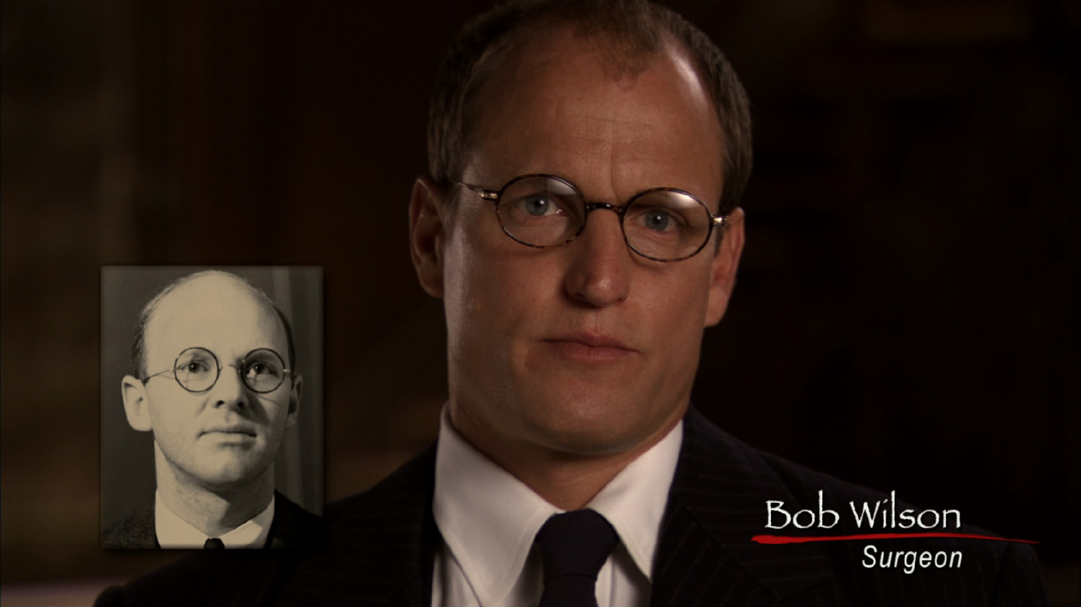

An accomplished actor in film, television and on the stage, Woody Harrelson has received Academy Award, Golden Globe, and Screen Actors Guild Nominations as Best Actor for his critically-acclaimed portrayal of controversial magazine publisher Larry Flynt in Milos Forman's drama, The People Vs. Larry Flynt. Set for release in 2007 are The Grand, an ensemble comedy for director Zak Penn, and No Country for Old Men, directed by Ethan and Joel Cohen and costarring Javier Bardem, Josh Brolin and Tommy Lee Jones. Past film credits include After the Sunset, Play it to the Bone, the Thin Red Line, The Hi-Lo Country, Ed TV, Wag the Dog, Welcome to Sarajevo, Kingpin, Natural Born Killers, Indecent Proposal, White Men Can’t Jump, The Big White, A Scanner Darkly, North Country, The Prize Winner of Defiance, Ohio, and A Prairie Home Companion. Harrelson recently wrapped Battle in Seattle costarring Charlize Theron and Andre Benjamin. He is currently shooting Transsiberian for director Brad Anderson.

Harrelson first endeared himself to millions of viewers as a member of the ensemble cast of NBC's long-running hit comedy,”Cheers.” For his work as the affable bartender Woody Boyd, he won an Emmy in 1988 and was nominated four additional times during his eight-year run on the show. In 1999, he gained another Emmy nomination when he reprised the role in a guest appearance on the spin-off series “Frasier.” He later made a return to television with a recurring guest role on the hit NBC series, “Will and Grace.”

Balancing his film and television work, in 1999 Harrelson revived a career-long commitment to the theatre by directing his own play, “Furthest from the Sun” at the Theatre de la Jeune Lune in Minneapolis. He followed next with the Roundabout's Broadway revival of the N. Richard Nash play “The Rainmaker” in 2000, Sam Shepard's “The Late Henry Moss” in 2001, John Kolvenbach's “On an Average Day” opposite Kyle MacLachlan in London's West End in the fall of 2002, and in the summer of 2003 Harrelson directed the Toronto premiere of Kenneth Lonergan's “This is our Youth” at the Berkeley Street Theatre. In the winter of 2005/2006 Harrelson returned to London’s West End, starring in Tennessee Williams’ “Night of the Iguana” at the Lyric Theatre.

A committed environmentalist, Harrelson joined his activism with his film efforts in Ron Mann's Go Further, a road documentary following Woody and friends on their bicycle journey down the Pacific Coast Highway from Seattle to Santa Barbara.

Along with being daddy to his three beautiful daughters, closest to his heart is www.voiceyourself.com, a website Harrelson co-created with his wife Laura Louie, which promotes and inspires individual action to create global momentum towards simple organic living and to restore balance and harmony to our planet.

Mariel Hemingway as Minnie Vautrin 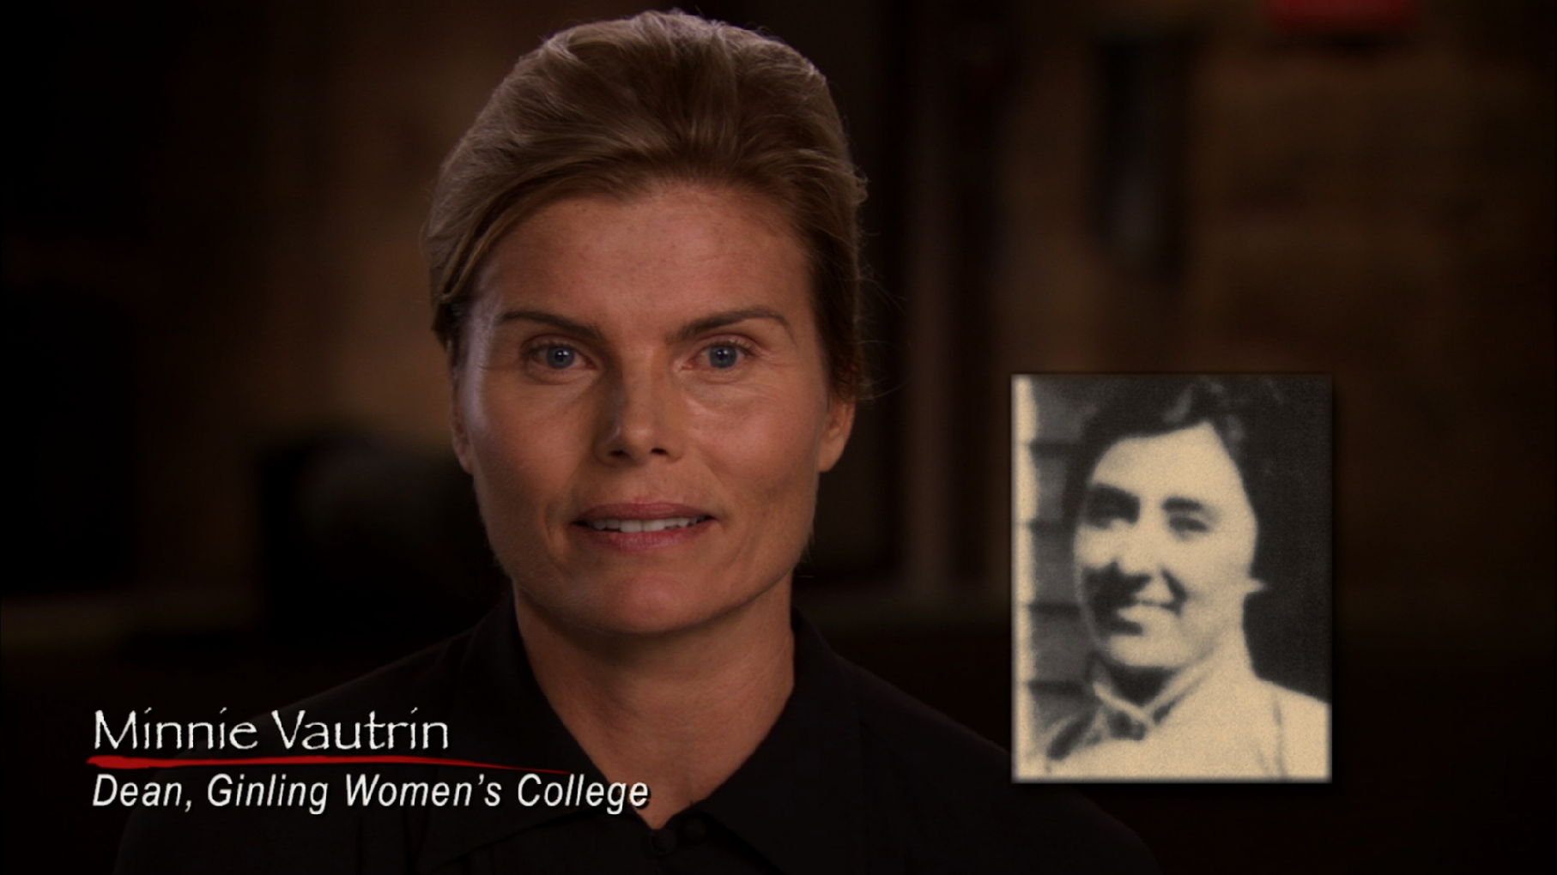

As the granddaughter of illustrious author Ernest Hemingway, Mariel was destined to be well-known and publicly recognized. At 13, Mariel became famous in her own right when she made her silver screen debut in Lipstick. Four years later her work in Woody Allen’s Manhattan earned her an Oscar nomination. She has since made 30 films and numerous television appearances, including the groundbreaking kiss with Roseanne on her hit show and a role in Steven Bochco’s highly acclaimed Civil Wars. Most recently, Mariel appeared in Rod Lurie’s film The Contender.

Now 44, Mariel is a wife and mother of two, Dree, 18, and Langley, 16. Over the last 22 years, she has also been pursuing her passion for yoga and is now perceived as a voice of holistic and balanced living. She has led yoga retreats all over America, sharing her insights about yoga, meditation, nutrition, and health. Her new business venture, In Balance, focuses on yoga products such as instructional DVDs, apparel, and accessories as well as balanced living products. Mariel is currently on tour promoting her second book, Living In Balance (Harper Collins San Francisco), a how-to guide to finding one’s own balance and health through self-empowering lifestyle techniques. She is also a holistic living spokesperson for Miraval Spas.

In 2003, she published her bestselling memoir, Finding My Balance. A truly insightful and inspiring story, the book is a portrayal of her life’s journey through the eyes of yoga and meditation. Along with her husband, Stephen Crisman, Mariel is producing documentaries that focus on spiritual and environmental issues. Additionally, she is developing a half hour comedy TV show for release in 2007.
JÜRGEN PROCHNOW as John Rabe

Jürgen Prochnow’s extensive film career includes credits as diverse as Wolfgang Petersen’s Das Boot (in which he memorably played the submarine captain), Air Force One, Anthony Minghella’s The English Patient and David Lynch’s Dune.

Some of his other films include Ron Howard’s The Da Vinci Code, Armand Mastroianni’s The Celestine Prophecy, Reuben Leder’s Baltic Storm, John Carpenter’s In the Mouth of Madness, Danny Cannon’s Judge Dredd, Uli Edel’s Body of Evidence, John Irvin’s Robin Hood, Euzhan Palcy’s A Dry White Season, John Frankenheimer’s The Fourth War, Tony Scott’s Beverly Hills Cop II and Michael Mann’s The Keep.

His television credits include A&E’s “See Arnold Run,” HBO productions “Dark Asylum” and “Forbidden,” Fox’s “Heaven’s Fire,” NBC’s “Jewels” and CBS’s “The Fire Next Time.”

JOHN GETZ as George Fitch 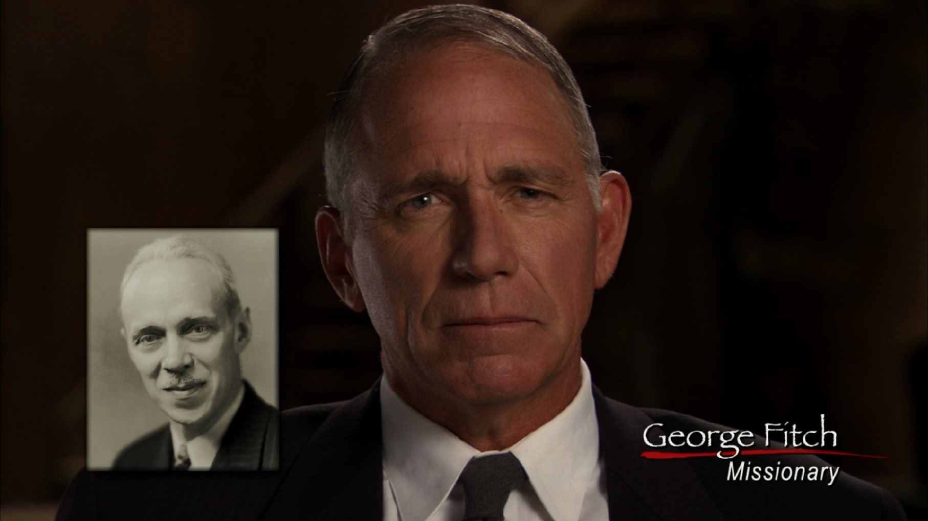

Stage-trained actor John Getz studied at the University of Iowa and the American Conservatory Theater in San Francisco. Performing in regional and New York theater, Getz appeared with the New York Shakespeare Festival and starred on Broadway in “M. Butterfly” and “They're Playing Our Song.” His early leading role in the Coen brothers' Blood Simple led to feature film roles in The Fly, The Fly II, Born on the Fourth of July, and 2004's A Day Without A Mexican to name a few.

Getz is soon to be seen in David Fincher's Zodiac. He is also remembered for his series regular roles on "MacGruder and Loud" and Lifetime's "Maggie." He was recently seen recurring on "Joan of Arcadia" on CBS and can currently be seen on ABC's "Day Break." When he's not acting, Getz enjoys racing sailboats.

Stephen Dorff as Lewis Smythe

Stephen Dorff’s recent credits include Robert Ludlum’s The Hades Factor, .45 with Milla Jovovich, Shadowboxer with Cuba Gooding, Jr. and Helen Mirren, and the Disney thriller Cold Creek Manor, with Dennis Quaid and Sharon Stone, for director Mike Figgis. He also starred in Scott Kalvert’s street gang drama Deuces Wild for MGM and as the champion of bad cinema in the John Waters comedy Cecil B. Demented, co-starring Melanie Griffith.

Dorff has an impressive list of screen credits, chief among them New Line’s Blade, in which he starred opposite Wesley Snipes and was awarded Best Villain at both the MTV Movie and Blockbuster Entertainment Awards. He also co-starred with Susan Sarandon in HBO’s Earthly Possessions, based on Anne Tyler’s novel about an unlikely romance between a young, fumbling bank robber and his hostage. Additional credits include Entropy, Blood and Win with Jack Nicholson, and opposite Harvey Keitel in City of Industry. He starred as the fifth Beatle, Stuart Sutcliffe, in Iain Softley’s Backbeat and as the notorious Candy Darling in I Shot Andy Warhol.

Chosen from over 2000 young men from around the world, he auditioned and won the coveted role of PK in John Avildsen’s “The Power of One” in 1992. For his performance, he was awarded the Male Star of Tomorrow Award from the National Association of Theater Owners.

ROSALIND CHAO as Chang Yu Zheng

Rosalind Chao has been a character actor since the age of 5. She began appearing in Peking Opera productions as brave young acrobatic warriors despite actually being an Asian American nerd from Orange County. In one of these productions, that she was spotted by a talent agent and began acting professionally.

Years later, while still in college, Rosalind made her first major television appearance when she guest starred as Soon Lee in the record breaking finale episode of M.A.S.H. Since then, she has become known to sci-fi fans as Keiko, the ship's botanist in "Star Trek: The Next Generation" and by film lovers as Rose Hsu in The Joy Luck Club.

Rosalind's numerous film credits include Wim Wenders' End of Violence, I Am Sam, What Dreams May Come, and her starring role opposite Chris Cooper in Thousand Pieces of Gold. More recently, she has appeared in the films Freaky Friday and Just Like Heaven as well as in recurring roles on television such as "Six Feet Under," "The O. C.," and the soon-to-be-aired HBO show "Tell Me That You Love Me."

Rosalind is married to actor Simon Templeman and they have a fourteen year old son, Roland, and a 7 year old daughter, Yi-Mei.

CHRIS MULKEY as Mills McCallum

In 2005 Chris Mulkey appeared in North Country starring Charlize Theron, and he can be seen in the upcoming mini-series “Daughters of Joy”, starring Robert Duvall and Thomas Hayden Church and directed by Walter Hil airing on AMC. He can also be seen in the upcoming independent features Dirty, Curiosity of Chance and Little Chenier,.

Mulkey co-starred in Radio, with Ed Harris, Cuba Gooding Jr. and Debra Winger, The Fan with Robert DeNiro, and Bullworth with Warren Beatty. Other films include Broken Arrow, 48 Hours, Gas Food and Lodging, Sugar Town, The Hidden, and many others, including the cult hit Patti Rocks, which was co-written and stars Mulkey.

For four years, Chris starred opposite Annie Potts and Lorraine Toussant in Lifetime’s acclaimed series “Any Day Now.” He has also had regular roles on such series as “Bakersfield PD”, “Twin Peaks”, “Arresting Behavior” and “Leaving LA”. His frequent guest roles over the years range from “CSI”, “CSI: Miami” and “Boomtown”, to “Charlie’s Angels” and “M.A.S.H”. He also appeared in TV movies such as “Vietnam War Stories,” “Behind Enemy Lines” and “Weapons of Mass Distraction” – all for HBO. Over the years at home or on the set, Mulkey has been playing the guitar and writing his own songs, some of which were used for “Any Day Now” and various movies. Mulkey lives in LA with his wife, actress Karen Landry, and his two daughters.

MICHELLE KRUSIEC as Yang Shu Ling

At the age of 12, Michelle Krusiec was scouted by a talent agent in her hometown of Virginia Beach. She began formally training at the Virginia Governor's Magnet School for the Arts and graduated with a Theatre and English Degree from Virginia Tech University. She studied on scholarship at Oxford before deciding to put her full attention into performance. Her first major series had Michelle globetrotting around the world as the host of “Travelers” for the Discovery channel, in which she visited over 50 destinations around the world.

Krusiec has graced films such as "Sweet Home Alabama," "Cursed," "Duplex," "Nixon"…but her uncanny performance in Alice Wu's feature Saving Face (Sony Classics 2005) garnered her a Best Actress nomination for the Golden Horse award, Asia's equivalent to the American Academy Award. Shy of winning by only a single vote, Krusiec walked away instead with the Golden Horse People's Choice Award for Best Film with Saving Face. Other awards garnered are the 2006 GLAAD Nomination for Best Film, 2005 AXA nomination for Best Performance.

Nationally, Michelle's performance as "Wil" in Saving Face has been described from “Hamlet-like” to “the Asian Sandra Bullock” to “Buster Keaton,” recognized by critics from the Hollywood Reporter, Variety, Slate Magazine, NY Post, Washington Post, just to name a few. Internationally, Krusiec has graced the pages of the leading press journals in Asia from Harper's Bazaar Taiwan, Liberty Times, China Times, Hong Kong's The Standard to…Milk Magazine.

In television, Michelle has made over 30 major guest appearances (not including her own NBC series One World) on primetime hits such as “Grey's Anatomy,” “Weeds,” “Cold Case,” “Without a Trace,” “NCIS,” “Monk,” “E.R.,” and HBO's dark comedy “The Mind of the Married Man.”

In 2002, Krusiec premiered her original one-woman show, "Made in Taiwan," to sold out crowds at the HBO Aspen Comedy festival. Hollywood Reporter named her one of the Top Ten Rising Stars at the festival and more recently again highlighted Michelle as part of their "Faces of Sundance" feature 2005 for her performance in "Saving Face."

She continues to develop "Made in Taiwan," a dark comedy about a mother who becomes obsessed with her husband's possible adultery. Michelle is currently developing MIT as a television pilot with producer Teddy Zee (Hitch, Saving Face).

GRAHAM SIBLEY as Miner Searle Bates

Michigan native Graham Sibley could have been a professional water polo player instead of an actor. He took up the aquatic sport in college after a season of basketball, but when the young student enrolled in his first acting class, he was hooked. He switched his major from film to theater, earning a BFA from Chapman University before going on to appear in nearly 50 shorts and student films. He also found work on stage all over the L.A. area and was awarded a Garland Performance Award for his work in “Little Malcolm and His Struggle.” In 2003, Sibley also appeared in commercials, which paid a little better than his more artistic work, so he left California and headed for New York. There, Sibley scored the lead in the gory flick Zombie Honeymoon, which recently was awarded with the 2006 Fuse/Fangoria Chainsaw Award for Best With Less (best horror film with a limited release). After a year in New York, he headed back to Los Angeles where he returned to the stage, joining a theater company called Ensemble Studio Theater, and also appeared in TV series including “Boston Public,” “The O.C.,” and “Strong Medicine.”

HUGO ARMSTRONG as Reverend John Magee

After graduating from CalArts, Hugo Armstrong went on to work with many prestigious theater companies in both Ireland and New York before returning to Los Angeles. He continues to be a part of new and innovative outsider works, including the world premieres of Cody Henderson's "Carrots for Hare", Travis Preston's "An Unseen Energy Swallows Space", and Jesse Miller's "Onionheads" at the Kennedy Center. In 2007 he will be seen again on the big screen in Cody Cameron's adaptation Mice and Men and Daniel Martinico's long awaited Bike Thief.

SONNY SAITO as Hiroshi Sakai, a Japanese soldier

Sonny Saito is a Japanese actor. His most recent works in the US are Clint Eastwood’s Letters from Iwo Jima; Big Dream Little Tokyo; and the daytime television series “Days of our Lives”. He is fluent in Japanese and English.

ROBERT WU as Li Pu, a Chinese soldier
Robert Wu has appeared in several award-winning films, including November opposite Courteney Cox, which garnered an Independent Spirit Award nomination and won a Sundance Film Festival Award; Kung Phooey!, which received the Special Jury Prize for Comedy at Worldfest Houston; S.F., which won the Grand Festival Award at the Berkeley Film Festival; and A Temp for All Seasons, in which he received the 168 Hour Film Festival Award for Best Actor.
His television credits include recurring appearances on “The Shield” and “Robbery Homicide Division,” as well as guest starring roles on “Numb3rs,” “The George Lopez Show” and “Threshold.” Wu recently joined NBC’s new comedy “Alpha Mom” as Morris, a polished but nerdy legal assistant. “Alpha Mom” follows the life of Jerri, a lawyer and breadwinner for her family as she tries to balance a full-time job, two small children and a not-so-thrilled stay-at-home husband.
Overseas, Wu has starred in China’s hit series “Human Cargo” and was also seen on stage in the Edinburgh Fringe Festival production of “All in the Timing.” A San Francisco native, Wu has performed with several Bay Area theatre companies, including Berkeley Repertory Theatre, California Shakespeare Festival and New Conservatory Theatre, where he earned the San Francisco Bay Guardian’s Great Performance Award for “The Nanjing Race.” Additionally, he appeared in “Paint Your Wagon” at the Geffen Playhouse, “Waiting For Lefty” at the Lee Strasberg Theatre and “The Comedy of Errors” at the Knightsbridge Theatre.
He currently serves as an acting coach for Changing Perceptions Theater by the Blind and Physically Disabled, an outreach theater company committed to education on disability issues.

Production Team:

Ted Leonsis
Producer

As one of the country's premiere businessmen, Ted Leonsis is a pioneer of the new media industry, a professional sports team owner and a philanthropist. He is a visionary in the Internet industry, having been involved since it's inception, and currently serves as Vice Chairman of America Online, LLC. As a sports team owner, Ted is the founder of Lincoln Holdings LLC, a sports and entertainment company, that holds ownership rights in several Washington, DC entities including 100% of the NHL's Washington Capitals and the WNBA's Washington Mystics. Ted also has recently become involved in the filmmaking business through conceptualizing and producing "Nanking," a documentary film that makes its world premiere at the 2007 Sundance Film Festival.

Ted, the longest-tenured senior executive at AOL, has served in multiple leadership capacities with the company including President of several business units including the AOL Core Service, AOL Web Properties, AOL Studios, and, most recently, the AOL Audience Business. With his consumer-driven focus, he has always been known to champion the members' voice for AOL.

Prior to joining AOL, Ted was the founder of several new media companies including Redgate Communications Corporation, a pioneering new media company that was the first company ever acquired by AOL in 1993. Additionally, Ted was the founder of six personal computer magazines, authored four books, and worked on the introduction of the IBM PC and the Apple MacIntosh. He also co-invented a very successful board game called "Only in New York." In addition, he served as a marketing executive with Harris Corp and Wang Laboratories.

As a sports team owner, in addition to being the majority owner of the Capitals and Mystics, Lincoln Holdings LLC also owns approximately 44% of Washington Sports and Entertainment Limited Partnership (WSELP), which owns the NBA’s Washington Wizards, the Verizon Center (formerly the MCI Center) and the Baltimore-Washington Ticketmaster franchise.

With the world premiere of "Nanking" at the 2007 Sundance Film Festival, Ted, making his production debut, has assembled a highly acclaimed filmmaking team including by the Academy-Award-winning writer/director team of Bill Guttentag and Dan Sturman. Nanking is a documentary film that serves as a powerful, emotional and relevant reminder of the heartbreaking toll war takes on the innocent as it tells the story of the Japanese invasion of Nanking, China, in the early days of World War II.

Additionally, Ted is a major philanthropist and is very involved with numerous charities, including Best Buddies, Hoop Dreams, See Forever Foundation, Youth Aids, and numerous others through the work of the Leonsis Foundation. He also once served as mayor of Orchid, Florida, and serves on the board of directors of his alma mater Georgetown University. Among his many honors, Ted has been named Washington's Businessman of the Year, a Washingtonian of the Year, one of the 20 most influential people in sports, one of America's most creative executives, and a top 10 entrepreneur of the year. Originally from Brooklyn, NY and later, Lowell, MA, he now lives in McLean, VA and Vero Beach, FL with his wife and two children.

Bill Guttentag
Writer /Director/Producer

In 2006 Bill Guttentag wrote and directed Live! which stars Eva Mendes, Andre Braugher, David Krumholtz, and Jay Hernandez. The film is produced by Mosaic Media Group. In 2003 he won an Oscar for the documentary Twin Towers (Universal). It was his second Academy Award; the first was in 1989 for You Don't Have to Die, a film he made for HBO. He has also received three additional Oscar nominations, as well as two Emmy Awards. His films have been selected three times for the Sundance Film Festival and have played and won awards at numerous American and international film festivals. Guttentag's films have received a number of special screenings, including one at the White House.

Bill Guttentag created and executive produced the NBC series “Crime & Punishment,” which ran for three seasons, ending in 2004. The series was part of the Law & Order family of shows, and was created with Dick Wolf, who was also an executive producer. Bill Guttentag has made documentary films for HBO, ABC, CBS and others. His HBO films include the Academy Award-nominated Crack USA, and Memphis PD: War on the Streets, for which he received the Robert F. Kennedy Journalism Award. In 1998 Guttentag directed Assassinated: The Last Days of Kennedy and King (executive produced by Oliver Stone) on the final year in the lives of Bobby Kennedy and Martin Luther King.

He wrote, produced and directed The “Cocaine War,” an ABC News/Peter Jennings Reporting special which involved months of accompanying DEA agents as they fought the drug war in South America. He also made 5 American Handguns - 5 American Kids, an Emmy-nominated HBO special on children and handguns. The film was honored by Jim and Sara Brady and The Brady Center to Prevent Handgun Violence. Bill Guttentag is a graduate of the University of Pennsylvania and the American Film Institute. In 1998-99 he was a John S. Knight Journalism Fellow at Stanford University. Since 2001 he has been teaching a class on the film and television business at the Graduate School of Business at Stanford.

Dan Sturman
Writer/Director

Nanking is Dan Sturman's directorial debut. Previously, Sturman produced Twin Towers, an Academy Award-winning documentary about two brothers -- one a firefighter, the other a policeman -- who died in the World Trade Center collapse. The film screened at the White House, at Sundance in 2003, and at numerous other festivals.

Between 2001 and 2003, Sturman produced three seasons of "Crime & Punishment," the award-winning NBC documentary series created by Dick Wolf and Bill Guttentag. The series was part of the "Law & Order" family of shows. Sturman has reported and produced for ABC News, CBS News, and the BBC while based in Los Angeles; for Reuters and NBC News while based in London; and for ABC News "20/20" in New York.

In 1992, Sturman was the associate producer of another Academy Award-winning documentary, A Time for Justice. The film, produced by Charles Guggenheim, commemorates the lives of the men, women, and children who were killed during the American Civil Rights Movement of the 1950's and 60's.

Dan Sturman is a magna cum laude graduate of Harvard University.

Michael Jacobs
Producer

Nanking is Michael Jacobs’ feature film producing debut. As a web entrepreneur and producer, deeply rooted in the entertainment industry, Mr. Jacobs developed a reputation for building cutting edge and bleeding edge software and sites over the past decade.

With funding from Softbank, he founded Oediv, a video sharing software company which allowed users to post, share and rate user created videos. He also produced Reelplay.com an online film market site, which allowed film makers and distributors to market and sell their films over the web.

As a founding producer at AOL's Entertainment Asylum, he created nearly 50 hours of the web's first regular celebrity web-video programming. He also developed sponsored programming around fashion and family content.

Prior to joining AOL, Mr. Jacobs produced and developed the first animated interactive daily comic strip in association with AOL - before animation software for the web like Flash or Shockwave existed. 'Zombie Detective' was named the best interactive comic by Entertainment Weekly, besting better-financed competition from Marvel.

Prior to developing Internet properties, Mr. Jacobs was a working screenwriter in Los Angeles. Mr. Jacobs is a graduate of Georgetown University and Franklin College, Lugano Switzerland. He is currently developing properties for both film and the Internet.

Buddy Squires
Director of Photography

Buddy Squires is an Oscar nominated filmmaker, an Emmy Award winning cinematographer and a co-founder of Florentine Films. He is best known as the director of photography of such films as: The Civil War, New York and Compassion In Exile. Squires has photographed six Oscar nominated films and one Academy Award winner. In 2006 he filmed Rehearsing a Dream currently short-listed for the 2007 Academy Awards.

Squires has been nominated eight times for Individual Achievement in Cinematography by the Academy of Television Arts & Sciences. Additionally, fifteen of the films he has photographed have been nominated for Primetime Emmy Awards and eleven have won. 2006 winners include PBS’s “Two Days in October” and HBO’s “I Have Tourette’s But Tourette’s Doesn’t Have Me.”

Nanking is the eleventh film photographed by Squires to be accepted in competition at the Sundance Film Festival. Other recent entries include Ring of Fire: The Emile Griffith Story (2005) and Special Jury Prize winner After Innocence (2005). Buddy Squires’ producing credits include: The Statue of Liberty (Oscar nomination) and Coney Island (Sundance Film Festival). He is the director of Listening to Children (Emmy nomination) and the co-director of Fast Eddie, Seeking Justice, People’s Poetry, and War Files.

PHILIP MARSHALL

Composer

Philip Marshall is a native Southern Californian and is the son of Jack Marshall (a prolific music composer for such television series “The Munsters,” “Laredo,” “Wagon Train” and many Tammy and Elvis movies). Philip attended the University of Irvine, majoring in Research Psychology and Music Composition. While at UCI, he wrote music for many acclaimed television commercials with companies such as IBM, Mattel, Yamaha, Xerox, Carl’s Jr, Subaru, Mazda and others. Philip was classically trained by the renowned Dr. Albert Harris and continues to orchestrate and conduct his own works.

In 1986, French director Lazlo Papas came to America looking for a talented music student to compose music for his short film End of the Rainbow. Respected for his symphonic work, Philip was highly recommended to score this unique art film that won awards at eight film festivals worldwide, including Best Film Score in Chicago. This led his career towards feature films and television.

Philip has been a very prolific composer in his own right. His feature film credits range from the Oscar winning Twin Towers to Endless Summer II, Trial and Error, Always, and Nell, to a six-film collaboration with composer Angelo Badalamenti on A Very Long Engagement, and psychological thrillers Arlington Road, Secretary, Dark Water, and the recent Sony Pictures release Wicker Man starring Nicolas Cage.

On the television side, Philip has scored over twenty films for Disney Channel, three films for the Family Channel, American Daughter and Oklahoma City for Lifetime, and the top rated legal drama Law & Order: Crime and Punishment for producer Dick Wolf. Philip’s talents don’t just lie in the film composing ranks. He was awarded a producing Grammy for BB King’s gold record Deuces Wild and wrote a Guitar Concerto for Classical guitarist Christopher Parkening.

When he’s not composing or playing guitar, Philip can be found participating in extreme sport competitions. He is a two time national Sailing Champion and competed professionally on surfing and windsurfing tours. And avid runner, he also enjoys golf, skiing, and mountain biking.

KRONOS QUARTET

Performers of Original Score

David Harrington, violin
John Sherba, violin
Hank Dutt, viola
Jeffrey Zeigler, cello

For more than 30 years, the Kronos Quartet—David Harrington and John Sherba (violins), Hank Dutt (viola) and Jeffrey Zeigler (cello)—has pursued a singular artistic vision, combining a spirit of fearless exploration with a commitment to expanding the range and context of the string quartet. In the process, Kronos has become one of the most celebrated and influential ensembles of our time, performing thousands of concerts worldwide, releasing more than 40 recordings of extraordinary breadth and creativity, collaborating with many of the world's most eclectic composers and performers, and commissioning hundreds of works and arrangements for string quartet. Kronos' work has also garnered numerous awards, including a Grammy for Best Chamber Music Performance (2004) and "Musicians of the Year" (2003) from Musical America.

Kronos' adventurous approach dates back to the ensemble's origins. In 1973, David Harrington was inspired to form Kronos after hearing George Crumb's Black Angels, a highly unorthodox, Vietnam War-inspired work featuring bowed water glasses, spoken word passages, and electronic effects. Kronos then went on to start to build a compellingly eclectic repertoire for string quartet, performing and recording works by 20th-century masters (Bartok, Shostakovich, Webern), contemporary composers (Sofia Gubaidulina, Arvo Part, Alfred Schnittke), jazz legends (Ornette Coleman, Charles Mingus, Thelonious Monk), and artists from even farther afield (rock guitar legend Jimi Hendrix, Indian vocal master Pandit Pran Nath, avant-garde saxophonist John Zorn).

Integral to Kronos' work is a series of long-running, in-depth collaborations with many of the world's foremost composers. One of the quartet's most frequent composer-collaborators is "Father of Minimalism" Terry Riley, whose work with Kronos includes the early Sunrise of the Planetary Dream Collector; Cadenza on the Night Plain and Salome Dances for Peace; 2002's Sun Rings, a multimedia, NASA-commissioned ode to the earth and its people, featuring celestial sounds and images gathered by the space agency; and, most recently, The Cusp of Magic, commissioned for Kronos in honor of Riley's 70th birthday celebrations and premiered by Kronos and Chinese pipa virtuoso Wu Man in 2005. Kronos has also collaborated extensively with composers such as Philip Glass, recording his complete string quartets and scores to films like Mishima and Dracula (a restored edition of the Bela Lugosi classic); Azerbaijan's Franghiz Ali Zadeh, whose works are featured on the full-length 2005 Kronos release Mugam Sayagi: Music of Franghiz Ali Zadeh; Steve Reich, whose Kronos-recorded Different Trains earned a Grammy; Argentina's Osvaldo Golijov, a MacArthur Fellow whose work with Kronos includes both compositions and extensive arrangements for albums like Caravan and Nuevo; and many more.

In addition to composers, Kronos counts many artists from around the world among its regular collaborators, including the legendary Bollywood "playback singer" Asha Bhosle, featured on Kronos latest CD, “You've Stolen My Heart: Songs from R.D. Burman's Bollywood;” the renowned American soprano Dawn Upshaw; Mexican pop-rockers Cafe Tacuba; the Romanian gypsy band Taraf de Haidouks; and the unbridled British cabaret trio, the Tiger Lillies. Kronos has performed live with the likes of icons Allen Ginsberg, Modern Jazz Quartet, Tom Waits, Betty Carter, and David Bowie, and has appeared on recordings by such diverse talents as singer-songwriters Dave Matthews, Nelly Furtado, Rokia Traore, Joan Armatrading, and Texas yodeler Don Walser.

Kronos' music has also featured prominently in other media, including film (Requiem for a Dream, 21 Grams, Heat, True Stories) and dance, with noted choreographers like Merce Cunningham, Twyla Tharp, and the duo Eiko & Koma setting pieces to Kronos' music.

The Quartet spends five months of each year on tour, appearing in concert halls, clubs, and festivals around the world including BAM Next Wave Festival, Barbican in London, UCLA's Royce Hall, Amsterdam's Concertgebouw, and the Sydney Opera House. Kronos is equally prolific and wide-ranging on disc. The ensemble's expansive discography on Nonesuch Records includes collections like Pieces of Africa (1992), a showcase of African-born composers that simultaneously topped Billboard's Classical and World Music lists; 2000's Kronos Caravan, whose musical "travels" span North and South America, Europe, and the Middle East; 1998's ten-disc anthology, Kronos Quartet: 25 Years; a celebration of Mexican culture, the Grammy- and Latin Grammy-nominated Nuevo (2002); and the 2003 Grammy-winner—Berg’s Lyric Suite.

Kronos' recorded work reveals only a fraction of the group's commitment to new music, however. As a non-profit organization based in San Francisco, the Kronos Quartet/Kronos Performing Arts Association has commissioned more than 450 new works and arrangements for string quartet. One of Kronos' most exciting initiatives in this area is the "Kronos: Under 30 Project," a unique commissioning and composer-in-residence program for composers under 30 years old, launched in conjunction with Kronos' own 30th birthday in 2003. By cultivating creative relationships with such emerging talents and a wealth of other artists from around the world, Kronos reaps the benefit of 30 years' wisdom while maintaining an approach to music making as fresh as the new century.

